STEM Kit Inventory

STEM Science Station: Sink or Float
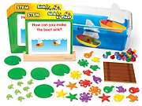

Description
From making a raft sink to getting a sea star to float, our innovative STEM Science Station is packed with hands-on experiments that help children explore and understand the science behind buoyancy! It includes 8 cards that prompt students to perform simple experiments…with all the hands-on materials to complete each one. Plus, the station features an engineering activity to extend the learning—and build critical-thinking and problem-solving skills! Includes a guide. The cards measure 8" x 8".
Develops skills in exploring buoyancy, using scientific inquiry skills, and using tools for observation and investigation.

For Ages 4+

Kit Includes
- 8 Activity Cards
- Wooden Card Stand
- 2 Plastic Boats
- Wooden Raft
- 30 Plastic Gems
- 20 Plastic Sea Animals
- 8 Plastic Frogs
- 5 Lily Pads
- Guide with Engineering Activity

STEM Science Station: Motion

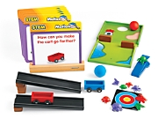

Description
Students get a hands-on understanding of objects in motion—as they race carts down ramps, launch “bugs” toward a target and more! Our innovative STEM Science Station encourages children to learn about motion through hands-on exploration. It includes 8 cards that prompt students to perform simple experiments…with all the hands-on materials to complete each one. Plus, the station features an engineering activity to extend the learning—and build critical-thinking and problem-solving skills! Includes a guide. The cards measure 8" x 8".
Develops skills in exploring motion, using scientific inquiry skills, and using tools for observation and investigation.

Ages 4+

Kit Includes
- 8 Activity Cards
- Miniature Golf Board
- Target Mat
- 2 Ramps
- 2 Foam Balls
- Wooden Card Stand
- 6 Wooden Blocks
- 2 Wooden Carts
- Launcher (Blue)
- 9 Plastic Bugs
- Guide with Engineering Activity

STEM Science Station: Magnets

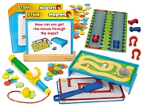

Description

Children use magnets to push cars up a ramp, move a magnetic mouse through a maze and more—as they learn all about magnetism & magnetic fields! Our innovative STEM Science Station encourages children to learn about magnetism through hands-on exploration. It includes 8 cards that prompt students to perform simple experiments…with all the hands-on materials to complete each one. Plus, the station features an engineering activity to extend the learning—and build critical-thinking and problem-solving skills! Includes a guide. The cards measure 8" x 8".
Develops skills in exploring magnets, using scientific inquiry skills, and using tools for observation and investigation.

Ages 4+

Kit Includes
- 8 Activity Cards
- Racetrack Mat
- Wooden Card Stand
- 3 Mouse Mazes
- Maze Platform
- 2 Horseshoe Magnets
- 2 Magnetic Cars
- 25 Non-magnetic Fish
- 50 Magnetic Fish
- Magnetic Mouse
- Magnetic Wand
- Magnetic Fishing Pole
- Guide with Engineering Activity

Alarm Your Pencil Box Lab

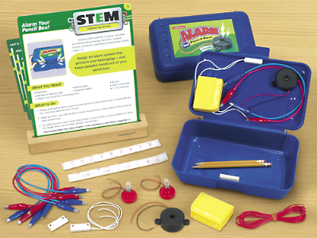

Description

With our innovative STEM lab, students really become part of the scientific process—as they build electrical circuits and research how alarm systems work…then design and build their own pencil box alarms! Designed to integrate STEM education into daily instruction, the project-based lab includes step-by-step activities that students complete in order—culminating in an in-depth engineering activity that really brings concepts to life. Students simply work through each activity with partners or in groups…and build the critical-thinking and problem-solving skills they’ll need for success in the future! Lab comes with all the materials students need to complete 4 activities—from doing Internet research to making series and parallel electrical circuits!

Ages 9+

Kit Includes:
- 2 Pencil Boxes
- 2 Buzzer Alarms
- 8 Alligator Clips
- Hook and Loop Dots
- 2 “AA” Battery Holders
- 2 Magnetic Switches
- 2 Light bulbs with Sockets
- Electrical Wire
- 4 STEM Activity Cards
- Wooden Stand
- Activity Guide with Reproducibles.

Don’t Lose Your Marbles Lab

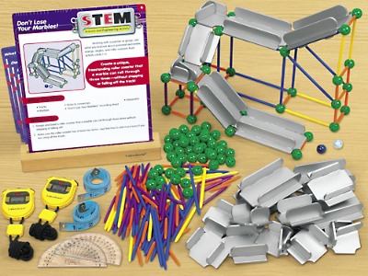

Description

With our innovative STEM lab, students really become part of the scientific process—as they explore potential & kinetic energy, how angles affect motion, and more…then design, build & evaluate their own roller coasters! Designed to integrate STEM education into daily instruction, the project-based lab includes step-by-step activities that students complete in order—culminating in an in-depth engineering activity that really brings concepts to life. Students simply work through each activity with partners or in groups…and build the critical-thinking and problem-solving skills they’ll need for success in the future! Lab comes with all the materials students need to complete 4 activities—from measuring angles to building a marble ramp!

Ages 9+

Kit Includes:
- 20 Roller Coaster Track Pieces
- 240 Sticks and Connectors
- 2 Marbles
- 2 Stopwatches
- 2 Protractors
- 2 Measuring Tapes
- 4 STEM Activity Cards
- Wooden Stands
- Activity Guide with Reproducibles

Space Lander Activity Lab

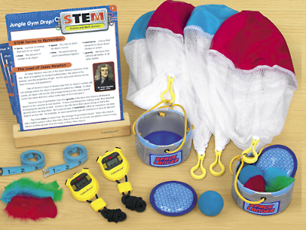

Description

With our innovative STEM lab, students really become part of the scientific process—as they learn all about Newton’s laws of motion and explore how parachutes work…then create their very own space landers! Designed to integrate STEM education into daily instruction, the project-based lab includes step-by-step activities that students complete in order—culminating in an in-depth engineering activity that really brings concepts to life. Students simply work through each activity with partners or in groups…and build the critical-thinking and problem-solving skills they’ll need for success in the future! Lab comes with all the materials students need to complete 4 activities—from researching parachutes to testing gravity’s effects on different objects!

Ages 9+

Kit Includes:
- 2 Space Landers
- 4 Parachutes
- 2 Foam Balls
- 2 Stopwatches
- 2 Tape Measures
- 6 Feathers
- 4 STEM Activity Cards
- Activity Guide with Reproducibles

GoldieBlox and the Builder’s Survival Kit

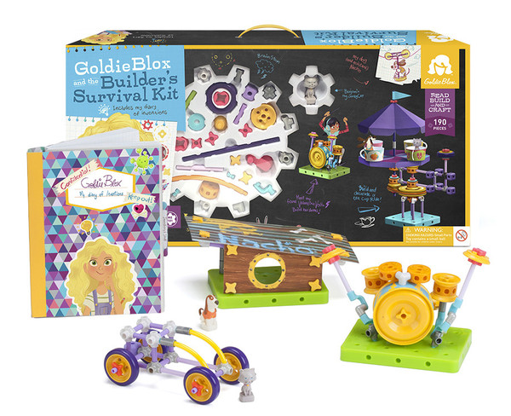
Description

GoldieBlox and the Builder’s Survival Kit is Goldie's ultimate builder's kit for the most adventurous innovator! With more than 190 pieces, GoldieBlox and the Builder’s Survival Kit offers hours of fun and endless possibilities. Goldie’s Diary of Inventions (included in the Builder’s Survival Kit), offers kids a wide-eyed perspective of Goldie’s world, her friends and family, and all of her secret inventions. From budding engineers to master architects, GoldieBlox and the Builder’s Survival Kit gives inventors the freedom to choose their own difficulty level. With included prompts, kids can build simple and small or big and bold. Kids develop spatial skills through basic engineering principles while building their reading skills and confidence in problem solving.

Ages 7-12

Kit Includes
- 1 storybook
- 3 character figurines
- 1 character bouncy ball
- 3 sheets of paper punch outs
- 1 sheet of stickers
- 2 big wheel ends
- 6 blox
- 4 elbow joints
- 4 corner joints
- 4 T-joints
- 4 cross joints
- 7 5-way joints
- 4 popcorn joints
- 4 coupler joints
- 6 angle joints
- 2 star couplers
- 8 long axles
- 15 short axles
- 19 mini axles
- 17 pegs
- 6 short flexi axles
- 6 long flexi axles
- 8 washers
- 10 spacers
- 2 cord lengths
- 1 crank
- 2 suction cups
- 12 star stoppers
- 1 noodle belt
- 4 tires
- 1 quarter pegboard
- 1 mini pegboard
- 1 table tent
- 6 wheel hubs
- 8 wheel ends

Snap Circuits Jr. 100 Experiments

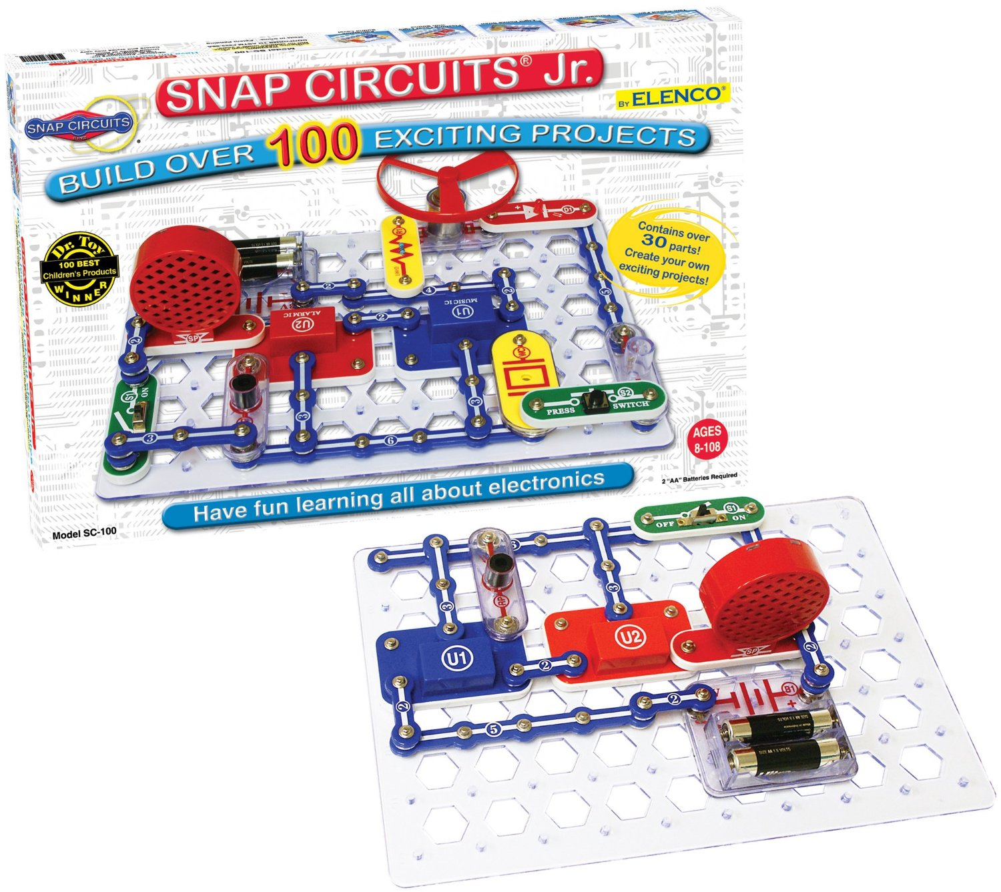

Description

Snap Circuits® makes learning electronics easy and fun! Just follow the colorful pictures in our manual and build exciting projects such as a flying saucer; alarms; doorbells and much more! You can even play electronic games with your friends. All parts are mounted on plastic modules and snap together with ease. Enjoy hours of educational fun while learning about electronics. No tools required. Includes Projects 1-101 manual.

Ages 8-108

Kit Includes:

- Base grid
- 1-Snap wire
- 2-Snap wire
- 3-Snap wire
- 4-Snap wire
- 5-Snap wire
- 6-Snap wire
- Whistle chip
- Slide switch
- Press switch
- Photoresistor
- Red Light Emitting Diode (LED)
- 2.5V Lamp
- Battery Holder
(Batteries NOT included)
- Speaker
- Music integrated circuit
- Alarm integrated circuit
- Space war integrated circuit
- Motor fan
- 100Ω Resistor
- 1 Red Jumper wire
- 1 Black Jumper wire

MaKey MaKey Standard Kit

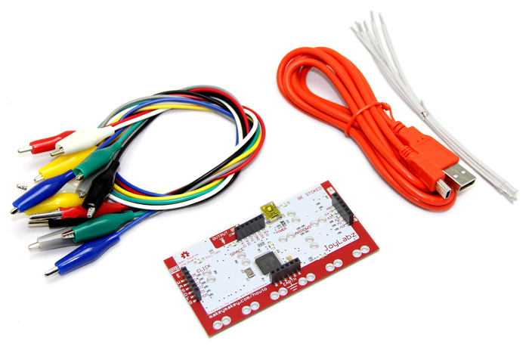

Description

Using the MaKey MaKey you can make anything into a key (get it?) just by connecting a few alligator clips. The MaKey MaKey is an invention kit that tricks your computer into thinking that almost anything is a keyboard. This allows you to hook up all kinds of fun things as an input. For example, play Mario with a Play-Doh keyboard, or piano with fruit! The MaKey MaKey uses high resistance switching to detect when you’ve made a connection even through materials that aren’t very conductive (like leaves, pasta or people). This technique attracts noise on the input, so a moving window averager is used to lowpass the noise. The on-board ATMega32u4 communicates with your computer using the Human Interface Device (HID) protocol which means that it can act like a keyboard or mouse. There are six inputs on the front of the board, which can be attached to via alligator clipping, soldering to the pads, or any other method you can think of. There are another 12 inputs on the back, 6 for keyboard keys, and 6 for mouse motion, which you can access with jumpers via the female headers
Ages 8+

Kit Includes:
- MaKey MaKey HID Board
- Alligator Clip Pack
- Mini-USB Cable
- Jumper Wire Pack

MaKey Makey Deluxe Kit

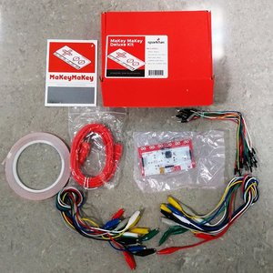

Description

Using the MaKey MaKey you can make anything into a key (get it?) just by connecting a few alligator clips. The MaKey MaKey is an invention kit that tricks your computer into thinking that almost anything is a keyboard. This allows you to hook up all kinds of fun things as an input. For example, play Mario with a Play-Doh keyboard, or piano with fruit! The MaKey MaKey uses high resistance switching to detect when you’ve made a connection even through materials that aren’t very conductive (like leaves, pasta or people). This technique attracts noise on the input, so a moving window averager is used to lowpass the noise. The on-board ATMega32u4 communicates with your computer using the Human Interface Device (HID) protocol which means that it can act like a keyboard or mouse.
The Deluxe Kit includes everything that the basic kit does plus another pack of alligator clips, a pack of jumper wires and a roll of copper tape so you can really go crazy!

Ages 8+

Kit Includes:
- MaKey MaKey HID Board
- 2 Alligator Clip Packs
- Mini-USB Cable
- Jumper Wire Pack
- Roll of Copper Tape

Squishy Circuits Hardware Kit
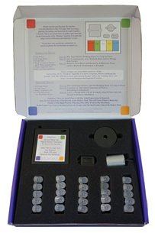

Description

Combine the fun of play dough with the amazement of light, sound, and motion with this introductory circuits kit. Learn the basics of electrical circuits hands-on with homemade play dough (recipe card included). Everything you need to create Squishy Circuits that spin, buzz, and light up!

All you need to do is mix up some play dough, install batteries, and you are ready to start exploring. The metal wires (leads) of the components in the kit are reinforced making them easier to insert in to the play dough and sturdy enough for even young children to use. The jumbo sized LEDs are bright and come in a variety of fun colors making for lots of artistic choice. What will you create with this kit?

Ages 5+

Kit Includes:
- 1 Motor
- 1 Piezoelectric Buzzer
- 1 Mechanical Buzzer
- 1 AA Battery Pack for 4 Batteries (Batteries NOT included)
- 25 LEDs in Red, Green, White, Yellow, and Blue

Ozobot Kit
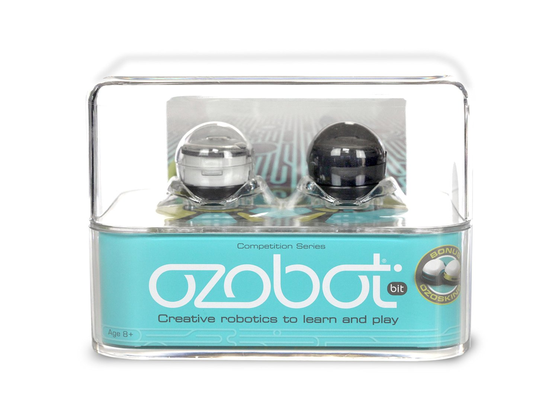
Description
Ozobot is a powerful learning tool that teaches children the basics of coding & programming in fun, interactive ways. Its easy to understand color based coding language makes Ozobot the perfect choice for introducing young minds to concepts that will be vital to their success in the 21st century. With Ozobot's unique ability to read and detect changes in color, kids can influence and control its behavior with simple combinations of red, green, blue and black on paper and digital tablets.
With structured STEM/STREAM lesson plans and workshops available for free on ozobot.com, teachers and parents can use Ozobot as a cutting edge educational tool that helps kids learn while playing.
Ages 14+

Kit Includes:
- Black Ozobot
- White Ozobot
- 2 Bonus Skins
- 2 Carrying Pods
- 2 Ozo USBs
- Ozo Cards
- Calibration Card

LilyPad Design Kit

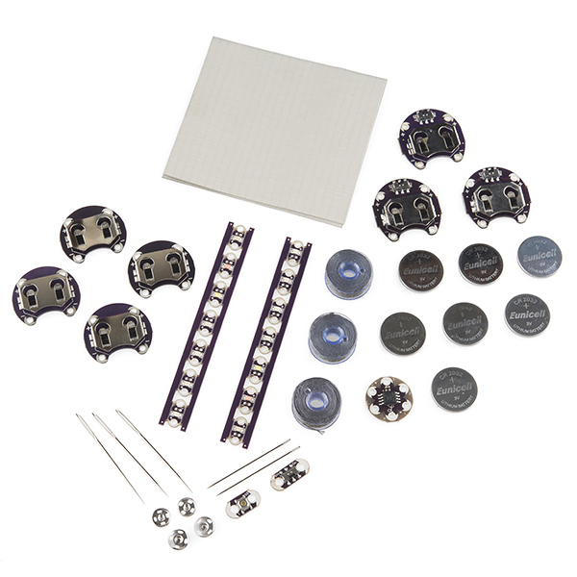

Description
The LDK has been carefully designed to walk you through the hurdles of getting started with e-textiles. If you don’t know how to sew, you should have a solid grounding by the time you finish these 6 experiments. If you don’t know anything about electronics, we’ll have you building microcontroller circuits in no time! Don’t know either? BUCKLE UP and let’s do this thing! The kit is divided into six experiments, so you’ll learn in six easy steps, with lots of links to explain sewing and electronics terminology and basic concepts. It’s easy to divide up into bite-sized lessons, or you can power right through the whole thing!
The circuits are shown alone, without any projects to obscure the circuit or limit your creativity, but every circuit shown has boundless potential for fun projects! If you put your circuits into a cool project or wearable, take a picture and send it in! We’ll be updating this page with inspirational photos of projects using the parts and circuits you’re learning. Project designs can be found at www.sparkfun.com/lilypaddesignkit .

Ages 10+

Kit Includes:
- 1 LilyPad Parts Box
- 1 Felt Sheet - 9" x 12"
- 1 Conductive Fabric - 6" x 6.5" Ripstop
- 1 Needle Set
- 3 Conductive Thread Bobbin - 30ft (Stainless Steel)
- 4 SimpleSnap (2 Male, 2 Female)
- 7 Coin Cell Battery - 20mm (CR2032)
- 1 LilyTiny
- 1 LilyPad Slide Switch
- 1 LilyPad Button Board
- 2 LilyPad Rainbow Led Strip
- 3 LilyPad Coin Cell Battery Holder - Switched - 20mm
- 4 Lilypad Coin Cell Battery Holder - 20mm

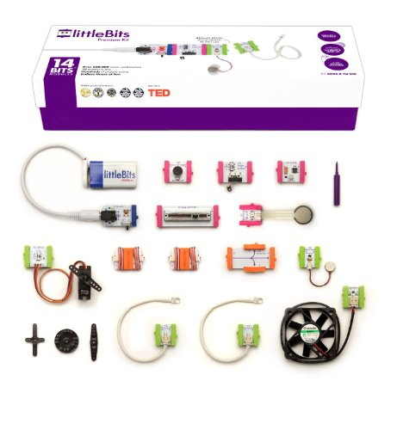
littleBits Premium Kit

Description
With this kit you will be able to make a multitude of projects including: a way to easily control a servo’s position, make a back massager, or even transform sound into light! It even comes in a snazzy cardboard box with magnetic closure.
littleBits is a library of discrete electronic components pre-assembled in tiny circuit boards. These simple, intuitive, space-sensitive blocks make prototyping with sophisticated electronics a matter of snapping small magnets together. With a growing number of available modules, littleBits aims to move electronics from late stages of the design process to its earliest ones, and from the hands of experts, to those of artists, makers, students and designers.
Ages 8+

Kit Includes:

- 1 Fan Bit
- 1 Slide Dimmer Bit
- 1 Roller Switch Bit
- 1 Branch Bit
- 1 Battery Power Bit
- 1 Pulse Bit
- 1 Vibration Motor Bit
- 1 Pressure Sensor Bit
- 1 Servo Bit
- 1 Sound Trigger Bit
- 2 Long LED Bit
- 2 Wire Bit
- 1 9V Alkaline Battery
- 1 9V Barrel Jack Cable
- 1 Screwdriver
- 1 vibeSnap
- Full-color Instruction Booklet

Deluxe Roominate Set: Wired Dollhouse Building Kit

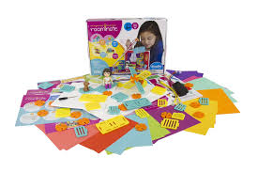

Description
Roominate is a dollhouse building/engineering kit created by two Stanford engineering graduate students to positively promote STEM to young girls. The concept is so clever, it could clearly extend to boys. The kits include everything you need to build a dream room or setting.
The Deluxe Roominate contains everything you nees to build her your miniature room. With twice as many building pieces and circuits as the Basic Roominate, you can build and wire up even more furniture and contraptions! Build more bunk beds, longer water slides, and bigger staircases, or wire up a working elevator and lamp with the motor and light circuits. The wall and floor panels can even be configured to build two-level structures, balconies, or backyards. The possibilities are endless! See more ideas on the Roominate website, along with pictures of what other girls have made!
Ages 6+

Kit Includes:
- 4 Wall/floor Panels
- 48 Furniture building pieces
- 16 Connectors
- 1 Motor
- 1 Light
- 2 Switches
- 2 Battery Packs
- Craft Paper
- Shiny Tape
- String
- Felt
- 8 Sheets of Stickers

